Consortium Agreement
(For attendance at another post-secondary institution)
Deadline for receipt:
Fall: August 1 Spring: December 1

The University of Mary Washington will enter into an agreement with another post-secondary institution to use financial aid funds to pay for approved courses. The financial aid programs available for Consortium Agreements include Federal Pell Grant, Federal Direct Loans, Federal Parent Loans (PLUS), Alternative Loans, and some Scholarship programs.

All students must submit the following items for files to be complete:
- A copy of the UMW Registrar Office "Request for Study at Another Institution" Form
- Approval email from the Registrar’s Office.
- Consortium Agreement from the other institution must be signed and returned. The Office of Financial Aid initiates this with the “host” institution. The requirement will show “satisfied” in your Eagle Net portal upon completion of the certification by the host institution.

Enrollment:
- Students who participate in a consortium agreement are required to enroll for a minimum of six (6) credits. These credits can all be taken at the Host Institution or by a combination with UMW classes.
- Less than full-time attendance can affect the amount of financial aid that a student is eligible to receive so it is recommended that the student take a minimum of twelve (12) credits combined to be considered full-time. However, students are permitted to take less or more credits depending on their needs.
- If you drop any courses at the Host institution they must notify the UMW Office of Financial Aid.
Note: Dropping courses may require the return of financial aid to federal programs.

UMW Endowed or Merit Scholarships:
- Students receiving certain types of scholarships may be limited in their ability to use these types of scholarships to pay for costs associated with the consortium agreement.
- Please check with the Office of Financial Aid to determine if your scholarship award will be affected.

Consortium Agreement Loan Options
- Federal Loan programs require enrollment in UMW approved courses of study for a minimum 10-week period enrolling in a minimum of six (6) credit hours. OR, a student may enroll for a minimum of six (6) credit hours in the UMW summer sessions where one session is taken at the host institution. Summer enrollment has very specific requirements for financial aid so it is recommended that a student talk with the Office of Financial Aid prior to enrolling in summer courses.
- Alternative Loan Programs have differing requirements regarding enrollment dates. Please contact the your preferred lender for this information.

Receipt of Funds:
- The University of Mary Washington will disburse aid to students based on the University’s regular disbursement schedule. If a Consortium Agreement is approved by the host institution, that institution agrees to wait until an approved date for payment in the amount that the student is receiving in financial aid.
- It is the student’s responsibility to ensure the Host institution receives the funds. Host institutions will not receive student financial aid funds directly from the University of Mary Washington.
- The Office of Student Accounts encourages students to enroll in direct deposit to receive the funds.
- If the student chooses not to enroll in direct deposit, the funds will automatically be sent in the on campus UMW mailbox.

Students are encouraged to contact the Office of Financial Aid to discuss this process. To set up an appointment, or speak to a financial aid representative, please call (540)654-2468, send an email to finaid@umw.edu, or visit the Financial Aid office, which is located in the Lee Hall Student Services Center.

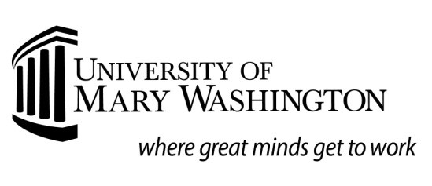
Request for Consortium Financial Aid- General
Deadlines for receipt: Fall: August 1
Spring: December 1
Summer: April 15

Name: _

UMW ID:
Academic Term: Term Dates: to _

Host School ID:________________ Date Of Birth: ______________________

Host Institution Information:
College Name:
Contact Name:
Address:
Phone: | Fax: | Email:
UMW Use ONLY. Has student completed ___Course Approval Form; UMW credits approved: ____
Signature of FA Staff Member: _______________________________________________

Host Institution Course(s) Costs (supply supporting documentation)
Tuition
Housing
Meals
Books and Supplies
Transportation
Program Fees
Consortium Fee
Other (specify)

Please process the appropriate financial aid for the above-named student. I understand that not
all aid previously awarded is eligible to be used for a consortium agreement and that it is my responsibility to submit all required documents to the Office of Financial Aid. Additionally, unless I have enrolled in Direct Deposit, I understand that funds will be sent to my mailing address. I understand that it is my responsibility to make full payment to above listed Host Institution.

Student signature Date

