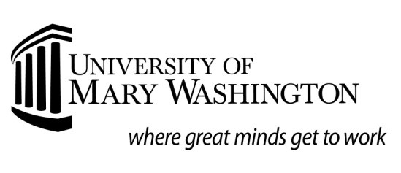
Summer Request for
Study Abroad Financial Aid
Deadlines for receipt: Fall: May 1
Spring: November 1
Summer: April 15
Name: _

Banner ID:
Academic Term: Program Dates: to

Study Abroad Program Information (do not use UMW Center for International Education (CIE))
Program Name:
Contact Name:
Address:
Phone: | Fax: | Email:
CIE Use ONLY. Has student completed _Course Approval; __received Acceptance into above program

UMW credits approved: _ Signature of CIE Staff Member: _

Study Abroad Program Costs
(print supporting documentation from program literature for items listed below)
Tuition & Education Fees
Housing
Meals
Books and Supplies
Transportation (include airfare, transfers, & local)
UMW Study Abroad Fee
Other (ex: Health Insurance, Visa, Passport)

Please process the appropriate financial aid for the above study abroad program. I understand that not all aid previously awarded is eligible to be used for study abroad and that it is my responsibility to submit all required documents to the Office of Financial Aid. Additionally, unless I have enrolled in Direct Deposit, I understand that funds will be sent to my UMW campus mailbox. I understand that it is my responsibility to make full payment to above listed study abroad program.

Student signature Date
SUMMER STUDY ABROAD INFORMATION
Deadlines for receipt: April 15

Students may have financial aid eligibility remaining from the previous academic year. That portion of aid can be used toward their Study Abroad. Contact the Financial Aid Office to determine eligibility. Financial Aid programs may include the Federal Pell Grant, Direct Student or Parent Plus Loans, Alternative Educational Loans, Scholarships or Grants.

All students must submit the following items for files to be complete:
- UMW "Summer Request for Study Abroad Financial Aid" Form and supporting documentation of program costs from the program literature. Note: This form must be signed off by the Center of International Education.
- Copy of “Course Approval Form”
- Copy of Acceptance Letter

Enrollment:
- Students who participate in summer study abroad programs are required to maintain half-time enrollment (6 credits or more) to receive their financial aid award.
- Should a student change their enrollment status, they should notify the UMW Center for International Education and the UMW Office of Financial Aid. Note: Changing enrollment may change financial aid eligibility and cause the return of financial aid to federal programs.

Summer Study Abroad Loan Options:
- Federal Loan programs, require enrollment in approved UMW study abroad program for a minimum of six (6) credit hours within the summer session.
- Alternative Loan Programs have differing requirements regarding enrollment dates. Please contact the appropriate lender for this information.

Receipt of Funds:
- The University of Mary Washington will disburse aid to the student based on the University’s regular disbursement schedule. If a Consortium Agreement is approved by the study abroad program, that program agrees to wait until an approved date for payment in the amount that the student is receiving in financial aid. The Financial Aid office will initiate this agreement and send to the study abroad program. The student will receive a signed copy when it is completed.
- It is the student’s responsibility to ensure the study abroad institution receives the funds. Study abroad programs will not receive student financial aid funds directly from the University of Mary Washington.
- The Office of Student Accounts encourages students to enroll in direct deposit to receive the funds.
- If the student chooses not to enroll in direct deposit, the funds will automatically be sent to the student’s campus UMW mailbox.
- Financial aid funds will not be available for required program deposit fees or upfront costs. The payment of financial aid funds for the summer semester will occur in late June, regardless of the program dates, assuming that all requirements have been completed and approved by the stated deadline.

After submitting all requested documents to the Financial Aid office, students are highly encouraged to make an appointment with the Assistant Director to discuss the process and financial aid package that you will be receiving. To set up an appointment, or speak to a financial aid representative, please call (540)654-2468, send an email to finaid@umw.edu, or visit the Financial Aid office, which is located in Lee Hall.

