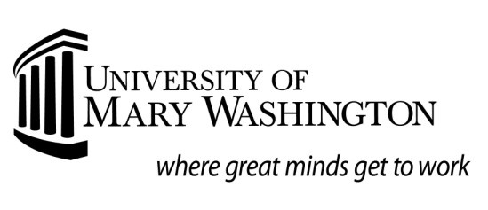
Request for Study Abroad Financial Aid:
Fall Semester, Spring Semester, or Academic Year
Deadlines for receipt: Fall: May 1
Spring: November 1
Summer: April 15
Name: _

Banner ID:
Academic Term: Program Dates: to

Study Abroad Program Information (do not use UMW Center for International Education (CIE))
Program Name:
Contact Name:
Address:
Phone: | Fax: | Email:
CIE Use ONLY. Has student completed _Course Approval; __received Acceptance into above program

UMW credits approved: _ Signature of CIE Staff Member: _

Study Abroad Program Costs
(print supporting documentation from program literature for items listed below)
Tuition & Education Fees
Housing
Meals
Books and Supplies
Transportation (include airfare, transfers, & local)
UMW Study Abroad Fee
Other (ex: Health Insurance, Visa, Passport)

Please process the appropriate financial aid for the above study abroad program. I understand that not all aid previously awarded is eligible to be used for study abroad and that it is my responsibility to submit all required documents to the Office of Financial Aid. Additionally, unless I have enrolled in Direct Deposit, I understand that funds will be sent to my UMW campus mailbox. I understand that it is my responsibility to make full payment to above listed study abroad program.

Student signature Date
Request for Study Abroad Information
Deadline for receipt:
Fall (or academic year): May 1
Spring: November 1

Financial Aid programs may include the Federal Pell Grant, Direct Student or Parent Plus Loans, Alternative Educational Loans, Scholarships or Grants.

All students must submit the following items for files to be complete:
- UMW "Request for Study Abroad Financial Aid" Form and supporting documentation of program costs from the program literature. Note: This form must be signed off by the Center of International Education.
- Copy of “Course Approval Form”
- Copy of Acceptance Letter

Enrollment:
- Financial Aid is based on full-time enrollment (12 credits or more). Should a student drop below 12 credits, their financial aid package could potentially be prorated or adjusted.
- Students should notify the UMW Center for International Education and the UMW Office of Financial Aid.

Scholarships:
- UMW Center for International Education (CIE) scholarship information can be found on the CIE website, international.umw.edu.
- Most scholarships disbursed by UMW can be used for study abroad. Students may apply for UMW scholarships through the Financial Aid Scholarship Application.
- Federal and State grants can be applied to study abroad.

Study Abroad Loan Options
- Federal Loan programs require enrollment in approved UMW study abroad program for a minimum 10-week period with a minimum of six (6) credit hours.
- Alternative Loan Programs have differing requirements regarding enrollment dates. Please contact the appropriate lender for this information.

Receipt of Funds:
- The University of Mary Washington will disburse aid to the student based on the University’s regular disbursement schedule. If a Consortium Agreement is approved by the study abroad program, that program agrees to wait until an approved date for payment in the amount that the student is receiving in financial aid. The Financial Aid office will initiate this agreement and send to the study abroad program. The student will receive a signed copy when it is completed.
- It is the student’s responsibility to ensure the study abroad institution receives the funds. Study abroad programs will not receive student financial aid funds directly from the University of Mary Washington.
- The Office of Student Accounts encourages students to enroll in direct deposit to receive the funds. If the student chooses not to enroll in direct deposit, the funds will automatically be sent to the student’s campus UMW mailbox.
- Financial aid funds will not be available for required program deposit fees or upfront costs. Fall disbursements to the student take place in early October. Spring disbursements to the student take place in mid February.

After submitting all requested documents to the Financial Aid office, students are highly encouraged to make an appointment with the Assistant Director to discuss the process and financial aid package that you will be receiving. To set up an appointment, or speak to a financial aid representative, please call (540)654-2468, send an email to finaid@umw.edu, or visit the Financial Aid office, which is located in Lee Hall.

