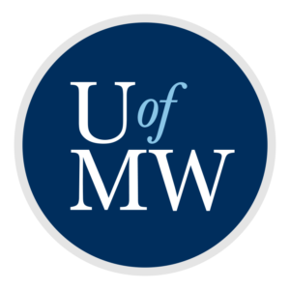
Student Employment Hire Form for Supervisors 2023-2024
University of Mary Washington

FOAP to Charge: Job Title/Position number (if known):
MyTime Supervisor’s Name: Date:
Banner ID # | Student’s Name  (No nicknames, please) | Pay Rate | First Time UMW Employee (y/n) | Preferred Start Date | Comments, Rate Changes, Stipend Breakdown, Etc.

Statement of WORK AUTHORIZATION:
STUDENTS MAY NOT BEGIN WORKING UNTIL A WORK AUTHORIZATION HAS BEEN EMAILED TO THE STUDENT/SUPERVISOR. Working prior to receiving a work authorization could result in penalty or monetary fines. Please sign below to begin the hiring process.
__________________________________________________________________________________________________
Supervisor signature Date

ELIGIBILITY FOR STUDENT EMPLOYMENT:
- All positions during the traditional academic year (fall and spring terms) require at least half-time enrollment (6 credits for undergraduate students, 5 credits for graduate students) in a degree-seeking program.
- Summer employment requirements: in a degree-seeking program, at least half-time enrollment in the previous spring term and at least half-time enrollment in the following fall term. Enrollment during the summer is not a requirement for summer employment.
  - Seniors graduating in the spring term are not eligible to work during the following summer term.
  - Incoming freshmen starting enrollment in the fall term are not eligible to work during the prior summer term.
- Effective Spring 2016: Only Federal Work-Study jobs require the employee maintain a 2.00 CGPA and Satisfactory Academic Progress with the Office of Financial Aid. Non-FWS jobs do not have the same GPA and academic progress requirement; however, some departments may have their own GPA and academic progress requirements. Students who are in danger of academic probation or suspension are encouraged to book an appointment with an academic adviser to ensure academic success at UMW while maintaining a job.

