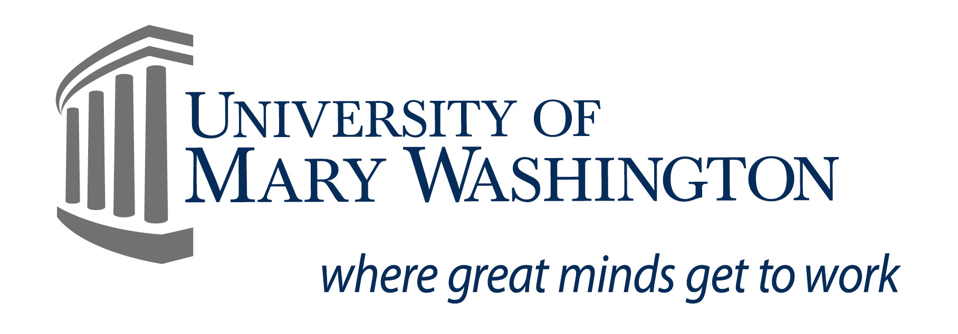**VIRGINIA JR. ACADEMY OF SCIENCE**

**75TH ANNUAL MEETING**

**Tuesday, May 17th – Thursday, May 19th**

**VJAS Media/Broadcast Release Form**

**University of Mary Washington ● Fredericksburg, Virginia**

I,                                 (student name), do hereby give the Virginia Academy of Science, the Virginia Junior Academy of Science, and the University of Mary Washington, their assigns and legal representative the irrevocable right to use my photograph or video images in all forms and media for education or other lawful purposes in its publications and displays. I waive my right to preview or approve the finished product, including written copy that may be created in connection therewith. I understand no fee will be paid to me now or in the future. I have read this release and understand its contents.

Teacher: Student:

School Name:                                                               Date:

Name of newspaper to which publicity release would be sent (if known):

**CONSENT**

*As the parent and/or guardian of the minor named above, I have the legal authority to execute the above release. I approve the foregoing and waive my rights in the premises.*

Guardian Name:

Relationship to minor:

Address:

City: State: Zip code:

Phone:

Parent/Guardian Signature: Date:

\*\**This form is required in order to attend the conference\*\**